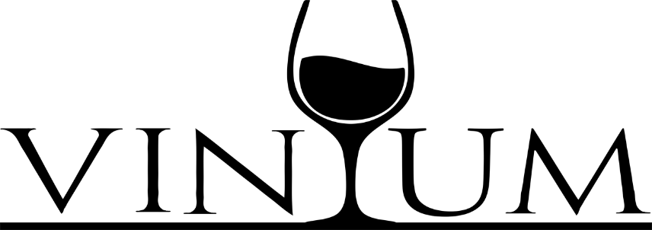
4 course prefixe menu for 2 people for $85
1st Course Choose one
Antipasto Toscano x 2 Burrata Platter x 2 Italian cured meats, cheese & mix olives Roasted peppers, Eggplant Caponata
2nd Course Choose Two
Rigatoni Matriciana: Plum Tomato sauce, guanciale (pork jowl), sharp pecorino Romano
Paccheri Beef Short Rib Ragu: Large rigatoni red wine braised beef short rib meat sauce
Spaghetti White Clams: Baby Clams, Olive oil, Garlic, Red pepper flakes, parsley
The Truffle: Purses of fresh pasta filled with cheese, creamy white truffle & mushroom sauce

3rd Course Choose Two
Boneless Beef Short Ribs: Braised in red wine, roasted root vegetables, fresh herbs, creamy truffled mashed potatoes
Double Cut Pork Chop: Pan roasted Berkshire double cut pork chop, rosemary garlic & balsamic reduction, sauté with mild and sweet peppers, broccoli rabe
Sole Oreganata: Basil pesto, Italian breadcrumbs, white wine lemon & butter, string beans & roasted rosemary potatoes
The Shoemaker: Chicken on the bone, sweet sausages, wine & lemon sauce, garlic, rosemary, peperoncini, splash of red wine vinegar & broccoli rabe
Roasted Organic Frenched Chicken Breast: Marsala reduction, wild mushrooms, fingerling roasted potatoes, string beans
Wild Caught Salmon: Asparagus, Roasted Potatoes, Grainy Mustard Sauce (surcharge $10)
Veal Chop Val D’Aosta: 18oz Veal chop pounded & breaded pan fried, topped with Italian roasted ham, white truffle cream, white wine sauce, melted fontina cheese (surcharge $20)
4th course
Mix Platter of Dessert & Cookies
Ask our beverage manager to add specialty cocktails or a discounted bottle of wine to your package

